Current Admin Report 2
Criteria 2
Results - Default 3
Results - Grouped By Course 4
Historic Admin Report 6
Criteria 6
Grouped by Course 8
Completed Users Report 9
Criteria 9
Results – Complete 10
Results – Incomplete 12
Summary Report 13
Criteria 13
Results - Default 14
Results – Stacked Column 15
Results – Stacked Bar Chart 15
Results – Pie Chart 16
Trend Report 18
Criteria 18
Results – Default 21

Current Admin Report

Criteria

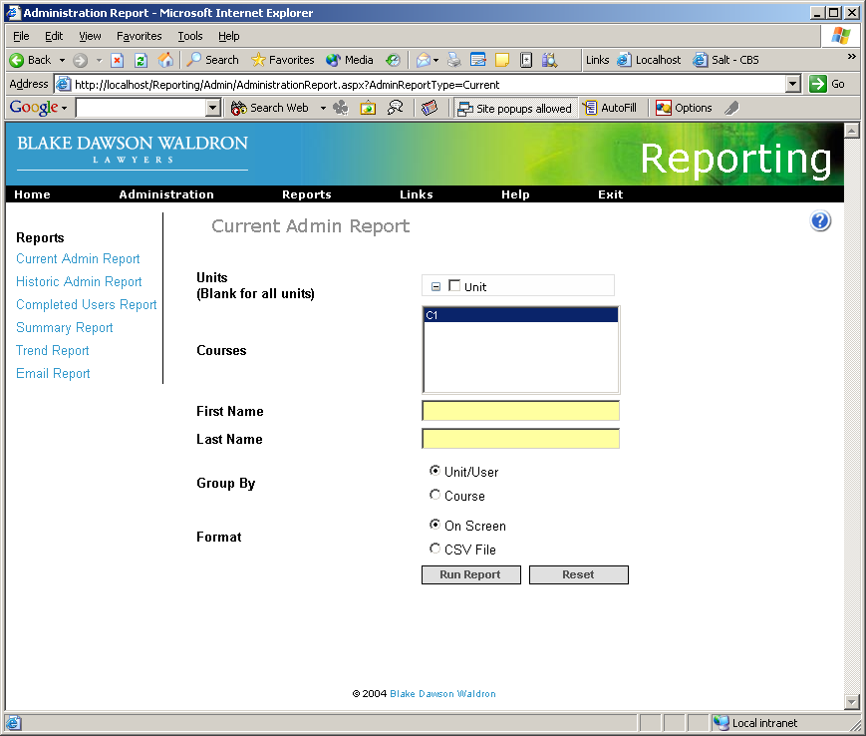

Results - Default
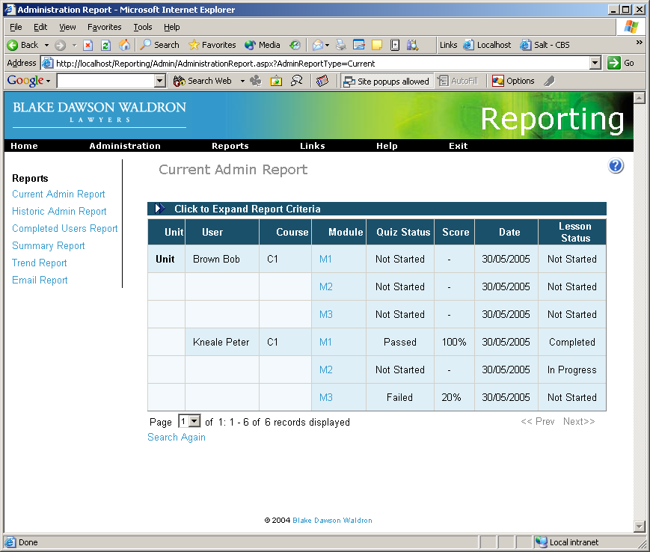

Results - Grouped By Course
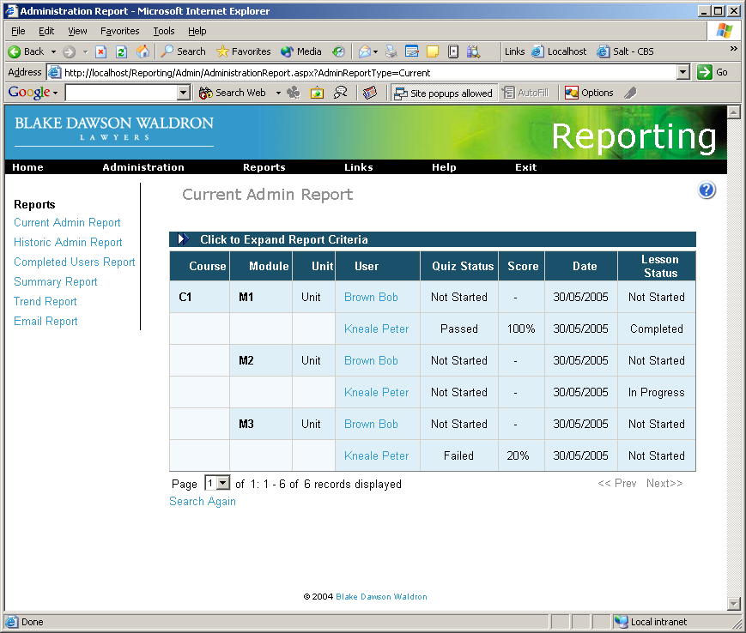

Results – Exported to CSV
Unit | User | Course | Module | QuizStatus | QuizScore | QuizStatusDate | LessonStatus | UnitID | UserID | CourseID | ModuleID
Unit | Brown Bob | C1 | M1 | Not Started |  | 30/05/2005 10:38 | Not Started | 1 | 3 | 1 | 1
Unit | Brown Bob | C1 | M2 | Not Started |  | 30/05/2005 10:38 | Not Started | 1 | 3 | 1 | 2
Unit | Brown Bob | C1 | M3 | Not Started |  | 30/05/2005 10:38 | Not Started | 1 | 3 | 1 | 3
Unit | Kneale Peter | C1 | M1 | Passed | 100 | 30/05/2005 10:59 | Completed | 1 | 2 | 1 | 1
Unit | Kneale Peter | C1 | M2 | Not Started |  | 30/05/2005 10:38 | In Progress | 1 | 2 | 1 | 2
Unit | Kneale Peter | C1 | M3 | Failed | 20 | 30/05/2005 11:00 | Not Started | 1 | 2 | 1 | 3

Historic Admin Report

Criteria
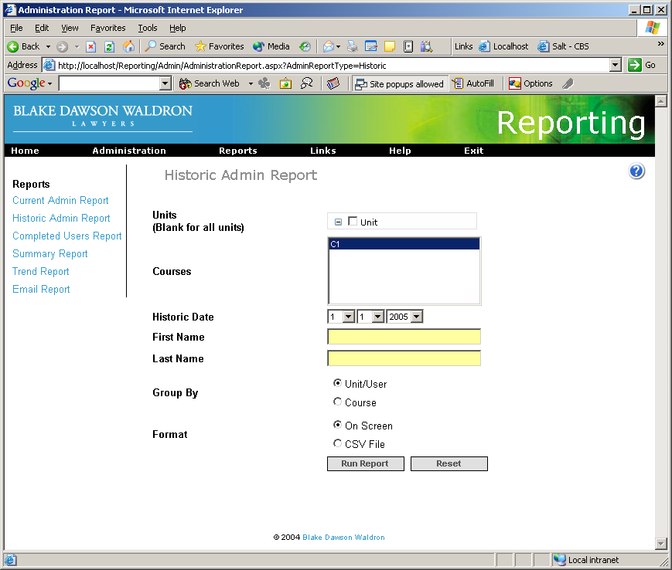

Results - Default
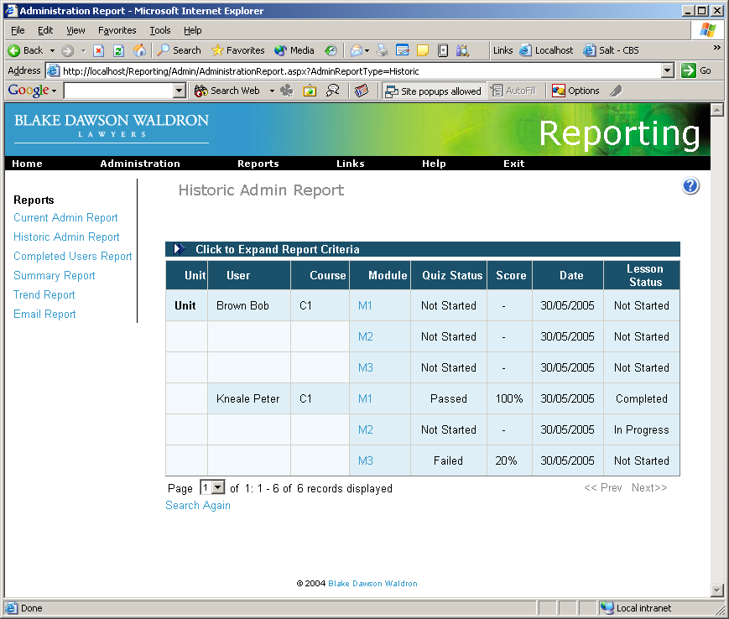

Grouped by Course

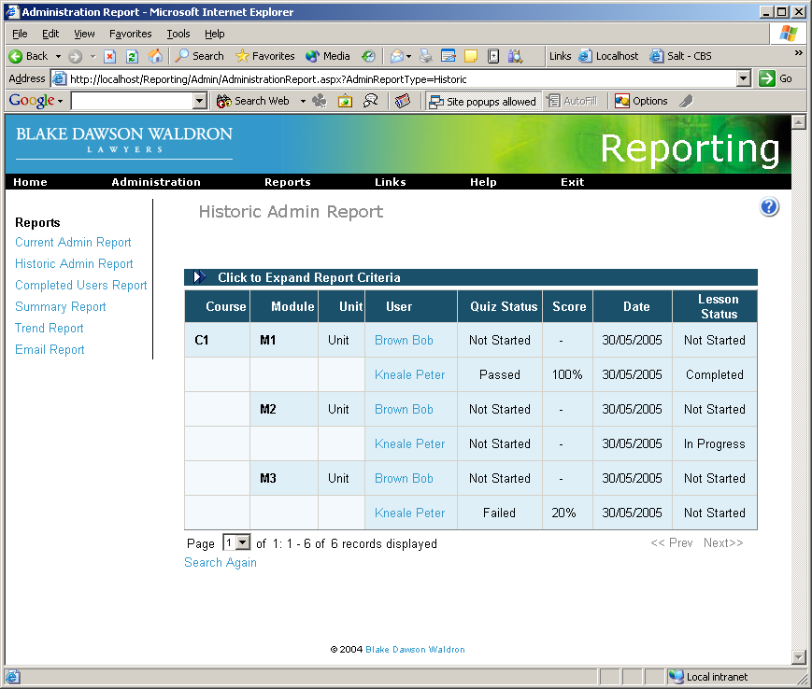

Completed Users Report

Criteria
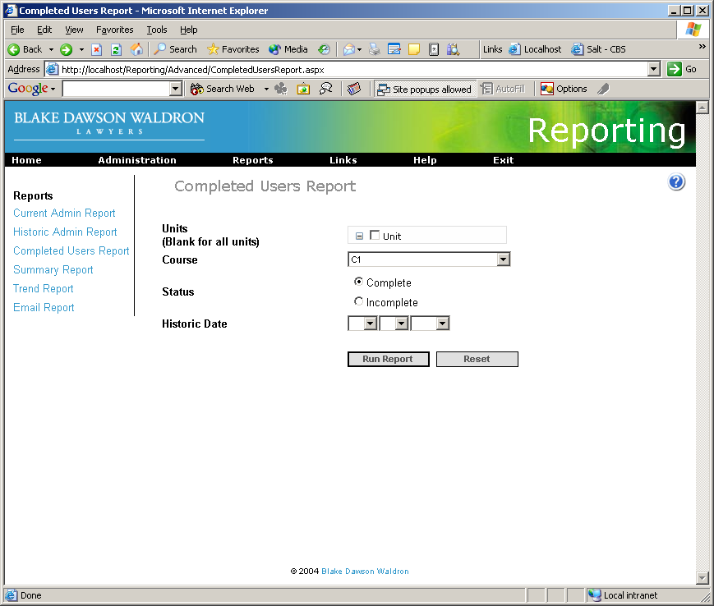

Results – Complete
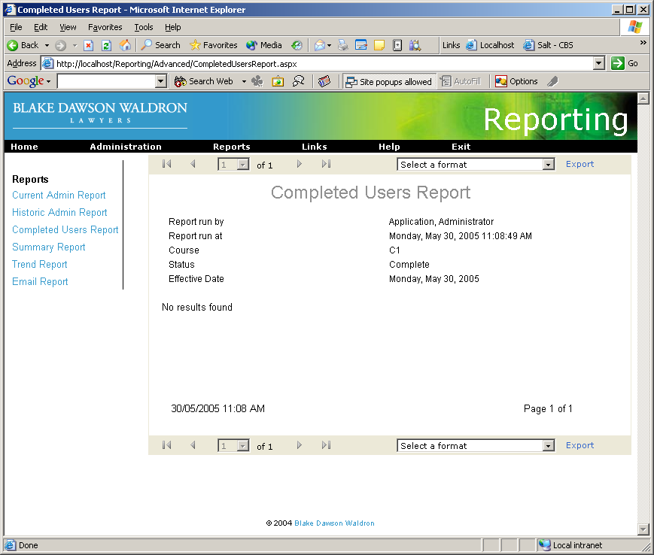

Results – Incomplete
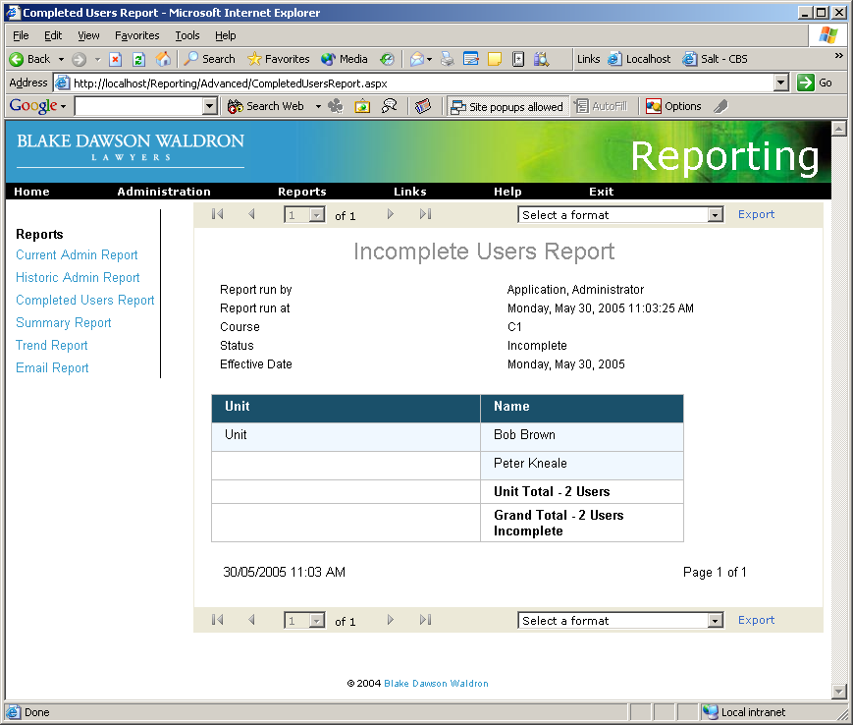

Summary Report

Criteria

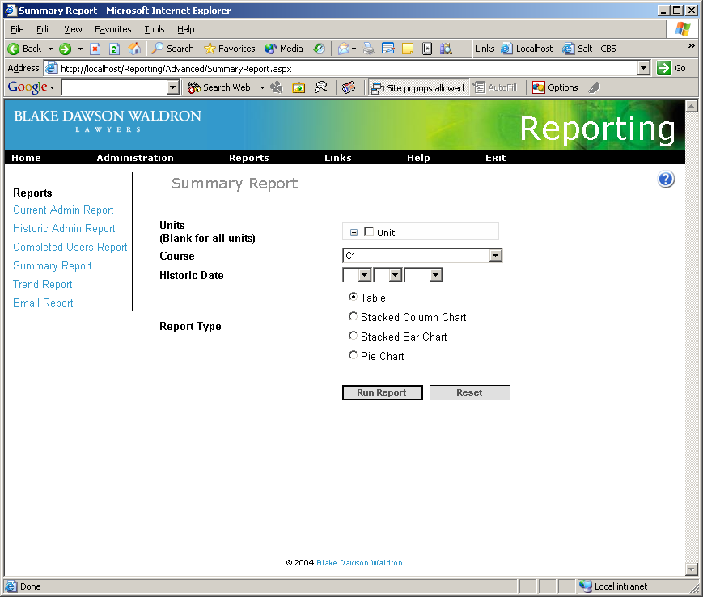

Results - Default
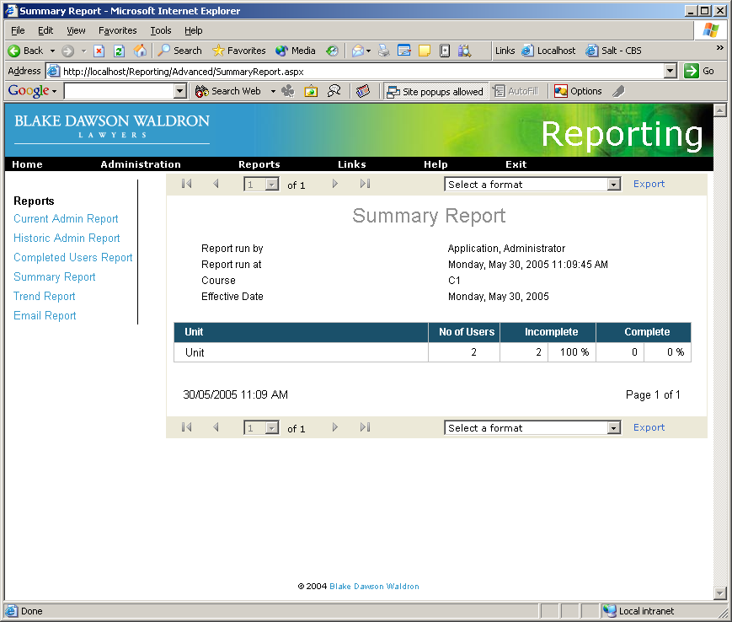

Results – Stacked Column
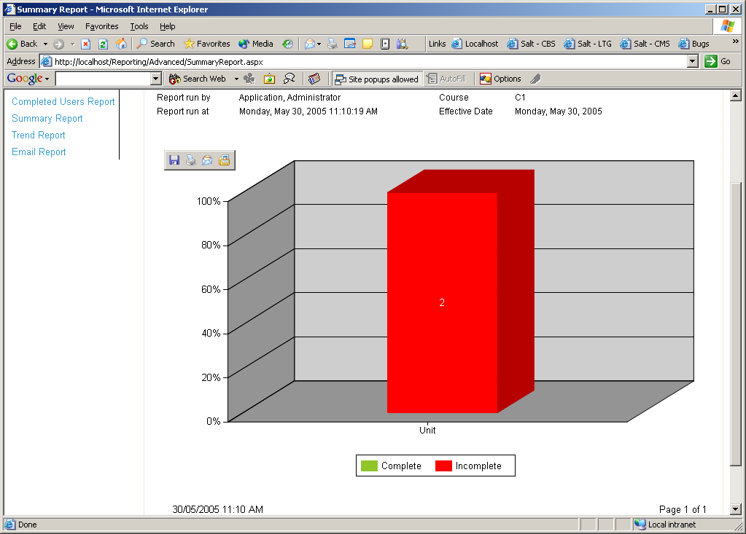

Results – Stacked Bar Chart

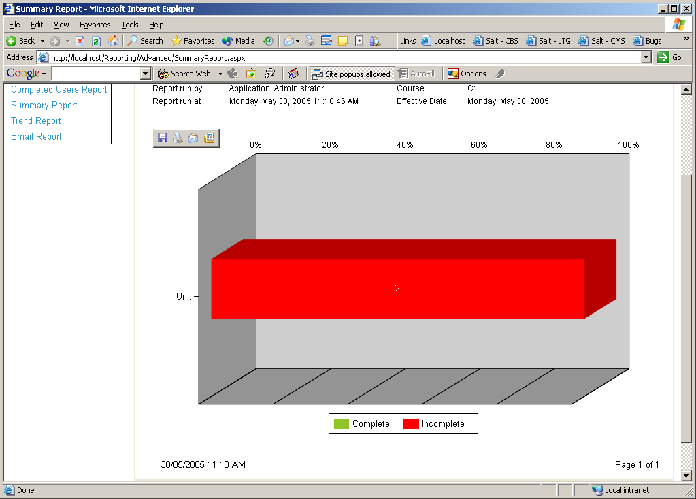

Results – Pie Chart

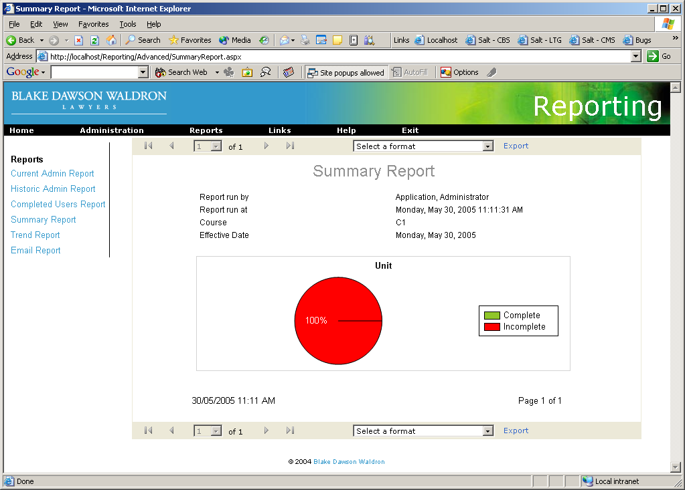

Trend Report

Criteria
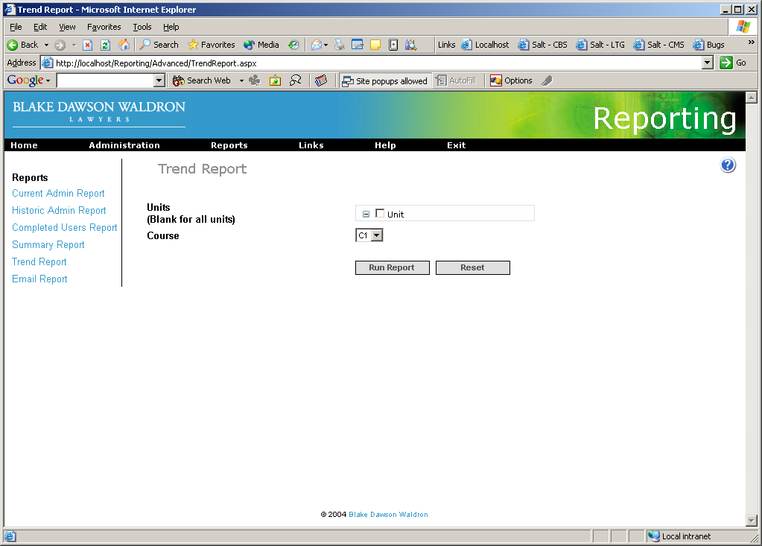

Results – Default
